Animations
App | Price | Description | FS | KS1 | LKS2 | UKS2
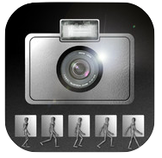 | FREE | iMotion HD: Stop motion animation app with facilities to edit after creation. |  | ✓ | ✓ | ✓
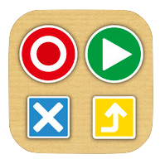 | FREE | Koma Koma: Stop motion animation app limited editing – can be used across whole school. | ✓ | ✓ | ✓ | ✓
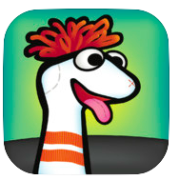 | FREE | Sock Puppets: Record audio to create puppet shows/conversations. | ✓ | ✓
 | FREE | Puppet Pals: Create stories with multiple characters and settings. (The paid app allows you to put your own pictures in) | ✓ | ✓ | ✓ | ✓
 | FREE  (ipads bought from Sept 1st 2013) | iMovie – allows you to create your own trailers and movies and stitch together films made in other apps. |  | ✓ | ✓ | ✓
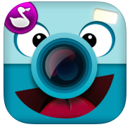 | FREE | ChatterPix Kids: Create talking pictures (easy to use). | ✓ | ✓ | ✓ | ✓
 | FREE | Tellagami: Create your own talking Avatar e.g. to explain concepts. (Pay for further features). |  | ✓ | ✓ | ✓
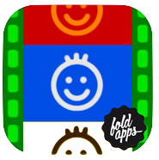 | FREE | Finger Paint Studio – A simple onscreen animation app.  (Also known as FoldFlip) | ✓ | ✓

Presentations
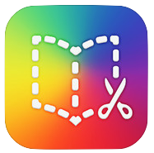 | £3.99  (FREE 1 book) | Book Creator: Creates eBooks, can be shared easily, add audio for talking books. | ✓ | ✓ | ✓ | ✓
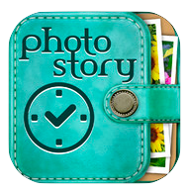 | FREE | Photostory: Create storyboards or photo collages. |  | ✓ | ✓ | ✓
 | FREE (Lite) | Popplet: Mind mapping tool, easy to use. | ✓ | ✓ | ✓ | ✓
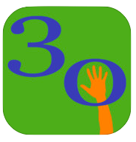 | FREE | 30 Hands: Create pictorial slides and add audio over the top. Great for reordering then narrating stories, presenting ideas etc | ✓ | ✓ | ✓ | ✓
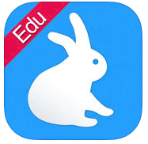 | FREE | Shadow Puppet: Add audio over images, add effects, nice map search tool for Geography included. | ✓ | ✓ | ✓ | ✓
 | FREE | Vittle: A free app for creating screen recordings on the iPad. | ✓ | ✓ | ✓ | ✓

Programming
App | Price | Description | FS | KS1 | LKS2 | UKS2
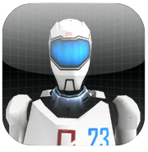 | FREE | A.L.E.X.: Program the robot to move to specified targets. |  | ✓ | ✓ | ✓
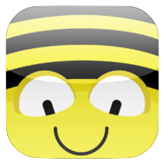 | FREE | Bee-Bot: Simple programming of movements – onscreen version of the physical Bee-bot. | ✓ | ✓ | ✓
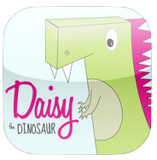 | FREE | Daisy the Dino: Simple object oriented programming clicking blocks together. | ✓ | ✓ | ✓
 | FREE | Hopscotch: Create games and use a variety of inputs. |  |  | ✓ | ✓
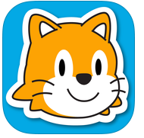 | FREE | Scratch Junior: Excellent programming app, good for story telling/curriculum links. | ✓ | ✓ | ✓ | ?  This year
Art and Photo editing
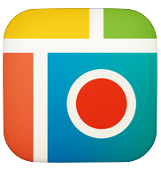 | FREE | Pic Collage: Great for creating collages of pictures for evidence/good for searching e.g. Right angle/sound hunts. | ✓ | ✓ | ✓ | ✓
 | FREE | Pic Stitch: Like Pic Collage but allows videos too. | ✓ | ✓ | ✓ | ✓
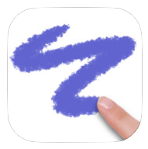 | FREE | Doodle Buddy: Great for creating art/doing quick fire maths. Shake to delete. Add your own backgrounds. | ✓ | ✓ | ✓ | ✓
 | FREE | Sketches: A good drawing app with multiple effects. | ✓ | ✓ | ✓ | ✓

Augmented Reality
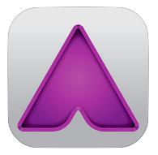 | FREE | Aurasma: Create your own augmented reality images e.g. for displays/evidence. |  | ✓ | ✓ | ✓
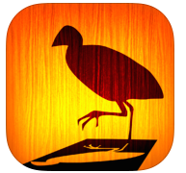 | FREE | ColAR Mix: Augmented reality targets that you can colour in yourself. | ✓ | ✓ | ✓ | ✓
Audio and Music
App | Price | Description | FS | KS1 | LKS2 | UKS2
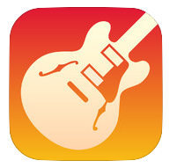 | FREE  (ipads bought from Sept 1st 2014) | Garage Band: Create music/podcasts |  | ✓ | ✓ | ✓
Virtual Worlds
App | Price | Description | FS | KS1 | LKS2 | UKS2
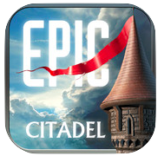 | FREE | Epic Citadel: Walk around a setting (No characters) | ✓ | ✓ | ✓ | ✓
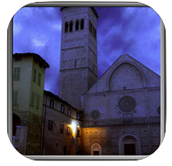 | FREE | Castlerama: Spooky setting | ✓ | ✓ | ✓ | ✓

Office Tools
App | Price | Description | FS | KS1 | LKS2 | UKS2
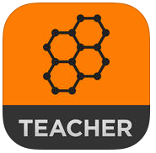 | FREE | Socrative Teacher: Create quizzes for the class. | For use by teacher
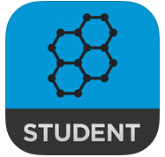 | FREE | Socrative Student: Allows children to send answers to teachers using an online response system. |  | ✓ | ✓ | ✓
 | FREE | Showbie: App for fast sharing of children’s work to teacher iPad. Ability to comment, mark and upload files to shared folders. Permission letter on website www.showbie.com | ✓ | ✓ | ✓ | ✓
 | FREE | Stage: A free visualiser. |  | ✓ | ✓ | ✓
Reading
App | Price | Description | FS | KS1 | LKS2 | UKS2
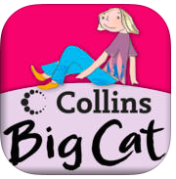 | FREE | Collins Big Cat: Stories for FS/KS1 | ✓ | ✓ | ✓
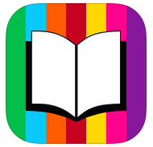 | FREE | Me Books: Beautifully created interactive books. Some free others can be purchased. | ✓ | ✓ | ✓

Tools
App | Price | Description | FS | KS1 | LKS2 | UKS2
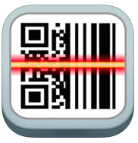 | FREE | QR Reader (by scan): Can be used to link to content e.g. online, treasure hunts etc. Good for evidencing work in books/for display e.g. from Purple Mash. | ✓ | ✓ | ✓ | ✓
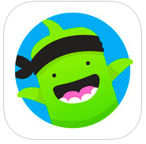 | FREE | Class DoJo: Behaviour management app. | ✓ | ✓ | ✓ | ✓
 | FREE | Touch Blur: Blur out children/names e.g. when posting work to Twitter/Website. | Teacher iPad

Maths (Maths Learning Centre Apps)
App | Price | Description | FS | KS1 | LKS2 | UKS2
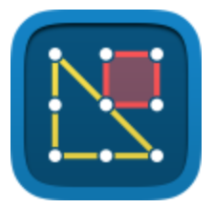 | FREE | Geoboard: The Geoboard app is a tool for exploring a variety of mathematical topics introduced in the elementary and middle grades. | ✓ | ✓ | ✓ | ✓
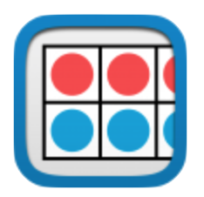 | FREE | Number Frames: help students structure numbers to 5, 10, 20, and 100. | ✓ | ✓ | ✓ | ✓
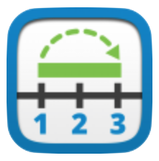 | FREE | Number Line: helps students visualize number sequences and illustrate strategies for counting, comparing, adding, subtracting, multiplying, and dividing. | ✓ | ✓ | ✓ | ✓
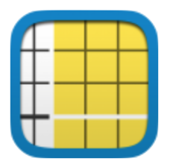 | FREE | Number Pieces helps students develop a deeper understanding of place value while building their computation skills with multi-digit numbers. | ✓ | ✓ | ✓ | ✓
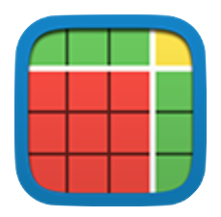 | FREE | Number Pieces Basic is a simplified version of Number Pieces. | ✓ | ✓ | ✓ | ✓
 | FREE | Number Rack facilitates the natural development of children’s number sense. | ✓ | ✓ | ✓ | ✓
 | FREE | Pattern Shapes: Students use Pattern Shapes to explore geometry and fractions, create their own designs, or filling in outlines. | ✓ | ✓ | ✓ | ✓

