Year 1 Homework
Week ending 11th December
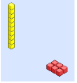

Dear Parents and Carers,

This week in English we have been writing instructions for how to trap a witch. On Monday, we returned to our classrooms to find a witch had visited and left the classrooms in an awful mess! We remembered to use capital letters, finger spaces and full stops as well as our ‘bossy’ (imperative) verbs.

In Maths, we have been focussing on place value and have been using the base ten to make numbers from 11-20. We also have looked at different ways we could represent the numbers. E.g. numicon, image, number sentence, ten frame, part-whole model.

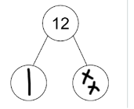
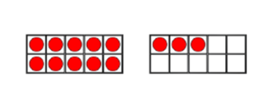

In Science, we had an interactive virtual session called ‘The tale of Three Winters’ with the rangers and actors from Chester Zoo to further our understanding of animals. The session furthered our understanding how local wildlife get ready for winter.

Thank you for your support,
Mr Young and Mr Hamm

ACTIVITIES

Reading – Read your Bug Club active learn book or your Home Reading book.

English – Chat Challenge! Play the ’bossy verb game’ on the back of the sheet.

- Take it in turns to roll the dice.
- Choose a bossy verb from the list e.g. roll a 1 then choose a verb from those listed in row number 1.
3. Can you think of an instruction starting with that bossy verb?
4. Tell the other player.

Maths – Play the game ‘Place Value Basketball’! First, click on the link attached below. Then, select numbers up to 19. Next, count the tens and ones carefully and click the correct answer.

https://www.topmarks.co.uk/learning-to-count/place-value-basketball
The Bossy Verb Game

 | mix | pour | stir
 | fold | cut | stick
 | spread | sprinkle | push
 | rip | shut | glue
 | stand | take | grab
 | sit | draw | look

