

**Pupil Premium and Covid Catch-up Funding Phase 1 2020-21**

**Governing Body and Leadership Statement**

At Black Horse Hill Infant School we have high aspirations and ambitions for all our pupils, and we are determined to ensure that all our pupils are given every opportunity to reach their full potential both in terms of their academic achievement and in their ability to make a full and positive contribution to our school community. We recognise that to fully meet the needs of our pupil premium children we need to identify any individual barriers to learning which they may have which prevents them from making progress in line with other children. Our focus is to ensure that the funding we receive has a positive impact upon our disadvantaged pupils.

Children and young people across the country have experienced unprecedented disruption to their education as a result of coronavirus (COVID-19). Those from the most vulnerable and disadvantaged backgrounds will be among those hardest hit. The aggregate impact of lost time in education will be substantial, and the scale of our response must match the scale of the challenge.

Schools’ allocations will be calculated on a per pupil basis, providing each mainstream school with a total of £80 for each pupil from FS2 to Year 2.

As the catch-up premium has been designed to mitigate the effects of the unique disruption caused by coronavirus (COVID-19), the grant will only be available for the 2020 to 2021 academic year. It will not be added to schools’ baselines in calculating future years’ funding allocations.

This report is slightly different this year for the following reasons:

1. We have no data (End of EYFS, Yr1 Phonic screening data or End of KS1 data) for the academic year 2019-20 because school was closed in March 2020 due to Covid-19.
2. The majority of our disadvantaged pupils did not attend school during the lockdown period. Many were unable to access home-learning opportunities after the initial paper pack of resources were sent out due to a lack of technology such as laptops or printers. Some parents/carers struggled to motivate and support their children at home during the lockdown period.
3. Baseline data for September 2020 shows that a significant number of children are working below age related expectations across the school and there needs to be a whole school focus on a recovery curriculum for all.
4. There has been an increase in the number of children who are eligible for pupil premium funding compared to last year

(2019-12% compared to 2020-20%).

1. We have used guidance and training from the Education Endowment Funding report into the effective use of disadvantaged funding and the Covid support guide for schools. This model promotes a tiered approach to Pupil Premium and Covid Catch-Up spending. The full report can be found at <https://educationendowmentfoundation.org.uk/evidence-summaries/pupil-premium-guide/>.

A summary is provided below.

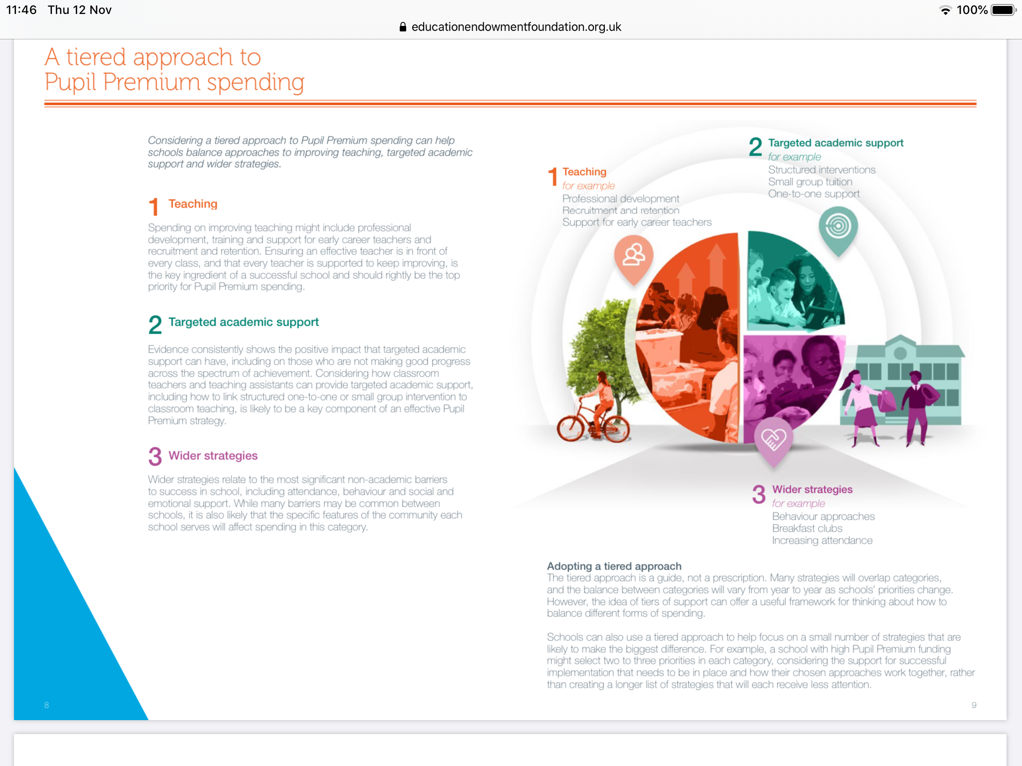

**Contextual Data**

|  |  |
| --- | --- |
| **Number of pupils and pupil premium grant (PPG) /Covid Catch Up Funding received** | |
| **Date of Pupil Premium Report October 2020** | **Date scheduled for Pupil Premium Review October2021** |
| Total number of pupils on roll | | 145 children  (+30 F1 pupils) |
| Total number of pupils eligible for PPG  There are no service children currently at the school. | | 29 children |
| **Total amount of PPG received (Financial Year)** | | £29,465 |
| **DfE Covid Catch-up funding** | | £6,856 |
| **Total Funding** | | £36,321 |

**Whole School data**

At the beginning of this academic year (September 2020) the children were assessed in reading, phonics, writing and maths against age related expectations. The data is shown below for each year group.

**Foundation Stage 2**

This table shows the number of children working at age related expectations on entry to Foundation 2.

|  |  |  |
| --- | --- | --- |
| **Area of Learning** | **Number of children** | **% of cohort** |
| Reading | 13 | 26% |
| Writing | 11 | 22% |
| Numbers | 32 | 64% |
| GLD baseline | 1 | 2% |

**Year 1**

This table shows the number of children working at age related expectations on entry to Year 1.

ARE= Age Related Expectations

|  |  |  |  |  |
| --- | --- | --- | --- | --- |
| Year 1 | Working significantly below ARE. | At risk of not meeting ARE. | On track for ARE | F2 December 2019  (Last data collection) |
| Reading | 15/45 (33%) | 19/45 (42%) | 10/45(22%) | 83% |
| Phonics | 13/45 (29%) | 17/45 (38%) | 14/45 (31%) | *See class assessment sheet* |
| Writing | 11/45 (24%) | 11/45 (24%) | 22/45 (49%) | 70% |
| Maths | 12/45 (27%) | 10/45 (22%) | 22/45 (49%) | 89% |

**Year 2**

This table shows the number of children working at age related expectations on entry to Year 2.

|  |  |  |  |  |  |
| --- | --- | --- | --- | --- | --- |
| **Year 2** | **Working significantly below ARE.** | **At risk of not meeting ARE.** | **On track for ARE** | **Yr1 Dec 2019** | **End of F2** |
| Reading | 17/50 (34%) | 14/50 (28%) | 19/50 (38%) | 70% | 73% |
| Phonics | 15/50 (30%) passed Phonic screening check Sept 20 | 0-10 words=16% 8/50  25+ words= 60% 30/50 | |  |  |
| Writing | 17/50 (34%) | 18/50 (36%) | 15/50 (30%) | 64% | 75% |
| Maths | 16/50 (32%) | 21/50 (42%) | 13/50 (26%) | 68% | 83% |

**Pupil Premium Baseline Assessment Data September 2020**

**Foundation Stage 2**

|  |  |  |  |
| --- | --- | --- | --- |
| **Foundation 2 (8 children)** | **Below** | **At Risk** | **On track** |
| Reading | 75% (6) | 12.5% (1) | 12.5% (1) |
| Writing | 75% (6) | 12.5% (1) | 12.5% (1) |
| Maths | 37.5% (3) | 0 | 62.5% (5) |

**KS1 data**

|  |  |  |  |
| --- | --- | --- | --- |
| **Year 1 (9 children)** | **Below** | **At Risk** | **On track** |
| Reading | (44%) | (34%) | (22%) |
| Phonics | (44%) | (22%) | (34%) |
| Writing | (44%) | (22%) | (34%) |
| Maths | (44%) | (12%) | (44%) |

|  |  |  |  |
| --- | --- | --- | --- |
| **Year 2 (12 children)** | **Below** | **At Risk** | **On track** |
| Reading | (58%) | (33%) | (9%) |
| Phonics | (42%) | (50%) | (8%) |
| Writing | (50%) | (50%) | 0 |
| Maths | (50%) | (50%) | 0 |

**Barriers to Achievement at Black Horse Hill Infant School**

These are common barriers that characterise underachievement in our disadvantaged children at Black Horse Hill but they are of course not barriers for all our disadvantaged children.

|  |  |
| --- | --- |
| **Key Issues** | **Barriers to achievement** |
| **Impact of Covid-19**  **(Lockdown)** | Lost learning due to schools closing in March.  Some children not accessing learning at home.  Gaps in key knowledge and skills across the curriculum.  Children used to having adult attention.  Excessive screen time for some children.  Poor listening and concentration skills.  Children not having the opportunity to experience cultural capital opportunities such as visits to the woods, zoo, farm park, beach and developing general knowledge plus broadening vocabulary.  Mental and Emotional impact on children. |
| **On-going disruption due to Covid**  **Bubble closures**  **Self-isolating pupils**  **Self-isolating staff** | Children not being able to access learning remotely due to lack of wi-fi, technology, printers.  Children are missing learning.  Parents/carers not feeling able to support their children at home or having to work from home themselves. |
| **Children have not remembered key skills for example, blending to read, grapheme recognition, number recognition and counting.** | There are significant gaps in children’s learning across the school in English and maths. |
| **Lack of school readiness in EYFS** | Poor listening, concentration and ability to build positive relationships.  Speech issues and lack of intervention.  Some children needing SALT referral has not happened.  Children lacking in physical skills/core strength.  Poor general knowledge and vocabulary development from enrichment opportunities e.g. zoo, woods, farm visits.  Independence |
| **Lack of parental engagement in learning in some families.** | No support with reading  Homework not completed |
| **Attendance for some Pupil Premium Pupils** | Missing learning leading to gaps in knowledge, vocabulary and skills. |

**Pupil Premium Funding Priorities 2020-21**

|  |  |  |
| --- | --- | --- |
| **Desired outcomes** | **Intended action** | **Funding** |
| To narrow the learning gap from the impact of school closures and to increase the number of children in KS1 on track to achieve age related expectations in reading and phonics. | **Quality Teaching for all (Tier 1)**  High quality teaching of reading across the school  Phonics lessons 5x a week  Additional teacher across the school to reduce group sizes in reading and phonics.  Teaching Assistants in each class  Staff training  NQT support  Read to Write Scheme  Training and support through the English Hub.  Leadership team to monitor data and progress  Bug Club Online reading system  **Targeted Support (Tier 2)**  Additional time dedicated to reading and phonics in timetable  Targeted intervention across the core subjects from Deputy Headteacher (released from classroom) in KS1.  Small Letters and Sounds group in KS1  SRP Reading intervention 1:1  SAFMEDS/PROBES  **Wider Strategies (Tier 3)**  Self-development programme for children lacking confidence and resilience. | NQT costs- £25,000 to release DHT/SENDCO  Read to Write programme  £1,250  Self-development Programme  £1,000 |
| To narrow the learning gap from the impact of school closures and to increase the number of children in KS1 on track to achieve age related expectations in mathematics. | **Quality Teaching for all (Tier 1)**  High quality teaching of mathematics across the school  White Rose maths scheme  Additional teacher across the school to reduce group sizes in mathematics.  Teaching Assistants in each class  Staff Training from Northwest Maths Hub for Subject leaders and teachers  NQT training  Leadership team to monitor data and progress  **Targeted Support (Tier 2)**  Targeted intervention from Teaching Assistant trained by Northwest maths Hub.  Catch up sessions with Teacher/TA  **Wider Strategies (Tier 3)**  Self-development programme for children lacking confidence and resilience | NQT costs- £25,000 to release DHT/SENDCO |
| To provide early intervention and support across EYFS classes to increase the number of children on track for GLD. | **Quality Teaching for all (Tier 1)**  High quality teaching in EYFS classes  Teaching Assistants in each class prioritising early reading, phonics and maths skills.  Staff training- EYFS Leader on Ruth Swailes training  Read to Write Scheme  Focus on developing core strength and physical skills to develop writing skills  **Targeted Support (Tier 2)**  Additional time dedicated to reading and phonics in timetable  NELI language intervention delivered in EYFS classes by teacher sand TAs  Keep up not catch up phonics in classes  Early maths skills intervention  **Wider Strategies (Tier 3)**  Parent workshops focusing on supporting your child at home  Physical activity programmes delivered by school sport coach. | Teaching Assistant support for intervention programmes.  £5,000 |
| To ensure that children are not disadvantaged in their learning if classes or individuals have to isolate due to Covid-19. | **Wider Strategies (Tier 3)**  Survey on access to laptops/wi-fi.  Purchase learning platform to support remote learning  Staff training  Learning packs provided if needed | See-Saw Learning platform and Tapestry  £400  Bank of school laptops/ipads for loan to Pupil premium families.  £1,000 |
| To support pupils with emotional difficulties across the school. | **Quality Teaching for all (Tier 1)**  Jigsaw PSHE scheme taught across the school  TA support in each class  **Wider strategies**  Bespoke Learning mentor work on a 1:1 /small group basis  Self-development programme | Learning mentor  £7,000 |
| To improve the attendance of pupil premium children whose attendance falls below 95%. | Monitoring of pupil attendance by Headteacher.  Attendance Panel interviews with Headteacher, Attendance officer and Learning Mentor |  |
| To enable all children to access the enrichment opportunities on offer at school. | **Wider strategies**  Payment for school trips and events  Subsidising attendance at extra-curricular clubs. |  |
|  | **Spending**  **(Includes DFE Covid Catch-up funding £6856)** | £40,650 |



**CATCH UP FUNDING TIERED MODEL**

**BLACK HORSE HILL INFANT SCHOOL**

**CATCH UP FUNDING TIERED MODEL**



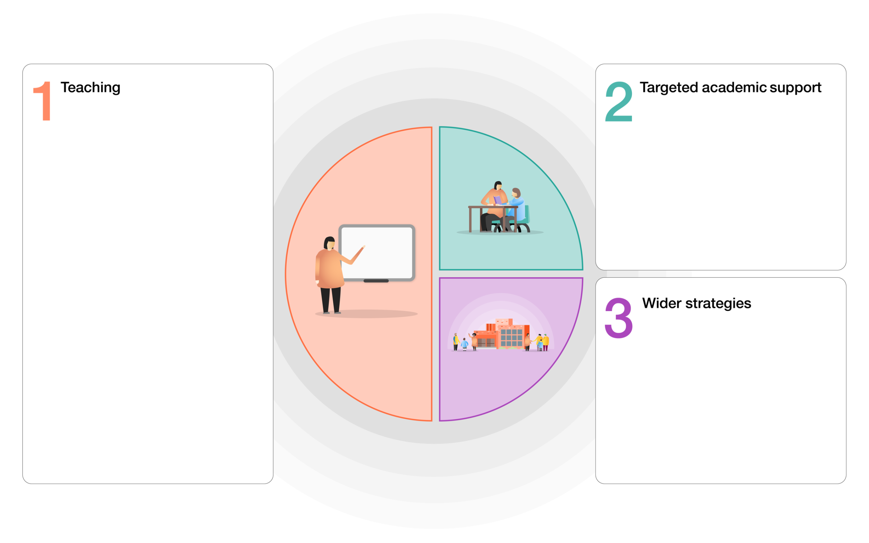

* Deputy HT (also SENDCO) not class commitment so delivering reading, phonics, writing, maths and processing interventions in KS1
* Small group phonic groups in KS1.
* Teaching assistants trained to deliver Successful Reading Partnership plus other interventions.
* Keep up not catch up procedures in class.

**Teaching and whole school strategies**

* High quality teaching across all classes.
* Highly trained Teaching Assistants
* Training for teachers from English Hub, Maths Hub and other agencies.
* Support for NQT.
* Key assessment points throughout the year to identify children at risk of not making expected progress.
* Quality curriculum resources such as Maestro, Read to Write and White Rose.
* Dedicated curriculum time devoted to supporting pupil’s emotional well-being and mental health.
* Dedicated curriculum time devoted to supporting pupil’s emotional well-being and mental health.
* Self-development programme in school.
* Learning mentor support for children and parents.
* Physical development activities from school sports coach.