Year 1 Homework
Week ending 15.10.21

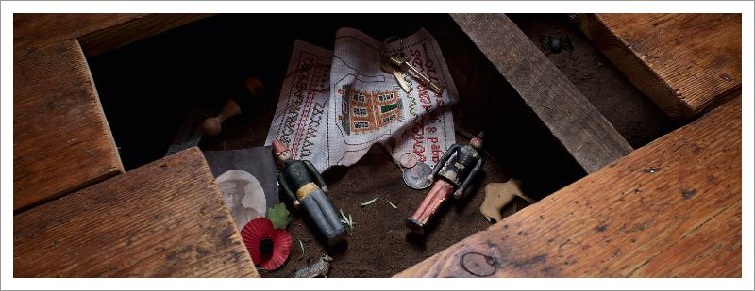

Dear Parents and Carers,

This week in English, we received a letter from Major Glad. He asked us to write back to him with some questions about the past so first we learnt that a question is a type of sentence. A question differs because it requires an answer and needs a question mark at the end of the sentence instead of a full stop. Over the course of the week, we looked at different letters that Major Glad had sent us. In one he shared how mischievous Amelia had been by sliding them between the old, rotten floorboards. We decided to plan our own message as Milly and Billy recounting what happened and how they felt when they found Major Glad and Major Dizzy in the present day.

In Maths this week, we have started learning about addition and subtraction. We looked at different whole numbers and used a range of practical equipment to split them into two different parts e.g. 5 can be split into 4 and 1, 3 and 2, 5 and 0 etc. We then made pictorial representations of this using a part-whole model (shown below). Also, we have introduced the children to the addition symbol ‘+’, so they could write their calculation correctly.
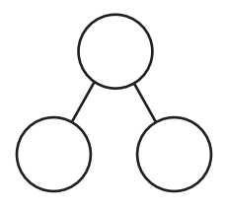

5

Thank you for your support,
Mr Young and Mr Hamm

ACTIVITIES
- Reading –Read your Bug Club active learn book.

- English –
Write a sentence sharing your favourite part of the story Major Glad, Major Dizzy that we have
been using as our main text in school. Remember to think of your idea first. Then tell someone
what your sentence is. Write your sentence. Finally check it back for sense and punctuation.

- Maths – On the next page complete the part-whole model activity to match the counters and calculate the whole number. Then write the addition sentences.
