Year 1 Homework
Week ending 27th November
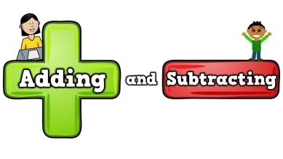

Dear Parents and Carers,

This week in English we have finished writing our own version of the fairy tale ‘Rapunzel’. Throughout our writing this week we have tried hard to remember our capital letters, full stops, adjectives as well as all the rich story book language that we have come across over the course of our time focussed on this fiction text.

In Maths this week we have continued our learning about subtraction. This week we have focussed on using a number line to represent our calculations when subtracting. Also, we have introduced the children to subtraction number sentences as part of fact families. Fact families revolve around 3 different numbers that are related. We have learned to write 8 addition and subtractions facts about them. This has been tricky so we have been practising lots!
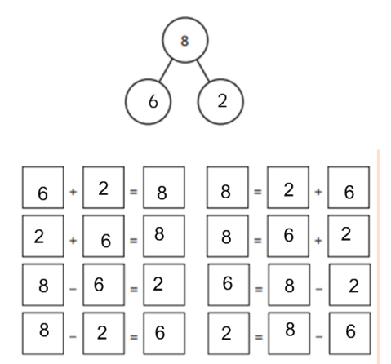

Thank you for your support,
Mr Young and Mr Hamm

ACTIVITIES

- Reading – Read your Bug Club active learn book or your Home Reading book.

- English – Read the attached list of alien or nonsense words. How many can your child read? It may be useful to remind your child to add the sound buttons on. This is something we do daily in school to support the decoding of words. Below is a quick example. The ‘qu’ is underlined as it is a digraph because the two letters make one phoneme (sound). The other three letters have a dot underneath as they are a single letter that makes a single phoneme (sound).
quemp

- Maths –Visit the website below. Select + and -. Then click up to 10. Can you complete the fact family number sentences? Don’t forget to check your answers. Do they make sense? For an extra challenge can you write the other 4 number sentences?
https://www.topmarks.co.uk/number-facts/number-fact-families
