Year 1 Homework
Week ending 7/5/21

Dear Parents and Carers,

In English, we have been reading a postcard that has been written by Erin (the main character from The Secret of Black Rock). During the week we have introduced the children to new vocabulary with the intention for them to able to use the new words and phrases such as luscious, turquoise, unnoticed and ‘hear waves lapping by the shore’. We have also looked at how postcards begin and end to understand their structure. Finally we looked at where to use capital letters and full stops in more detail (names, places and the personal pronoun ‘I’).

In Maths, we have begun our learning about fractions and this week we have been focussing on finding a half of a shape, object or quantity. The children have had the opportunity to use concrete manipulatives to practise finding half by sharing objects equally. Through our practise of this skill we have taught the children to represent their calculations pictorially using an image where the objects can be drawn one by one into two circles to be shared equally. Please find an example of this below.

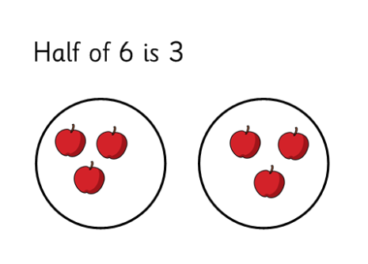

Thank you for your support,

Mr Young and Mr Hamm

ACTIVITIES

Reading – Read your Bug Club active learn book and your Home Reading book.
Maths – Look at the word problems below. Read the questions carefully and answer them as best as you can. Can you draw an image of your calculation? As a challenge, can you write a sentence for your answer e.g. 5 is half of 10.
English – Become a sentence doctor and add full stops and capital letters correctly to the postcard below.

Maths

- This morning Sarah made 8 cupcakes. Her brother ate half of them. How many are left?

- A lorry has 6 tyres. Half of them have a puncture. How many need to be repaired?

- 12 children were playing football. Half of them were wearing red shirts. Half of them were wearing green shirts. How many were wearing red shirts?

- Mark is 16 years old. His sister is half of his age. How old is his sister?

- A ladybird has 20 spots. Its friend has half the amount of spots. How many spots does its friend have?

English
English

Fix the sentences by adding full stops and capital letters.

Dear Year 1,

Hello! my name is erin and I live in a house by the sea with my Mummy and Archie, my dog

I love to lie unnoticed on the jetty where I can see beautiful birds, tall trees, luscious bushes and lots of amazing fish. today, I can hear waves lapping on the shore and fish splashing playfully in the turquoise waters

I love living here! I would love to go out to sea but I am not allowed

Love,
erin

Fix the sentences by adding full stops and capital letters.

