Home Learning Procedure 2020-21

Guidance to support pupils and families during a school closure

- INTRODUCTION
- HOME LEARNING FOR FOUNDATION 1 TO YEAR 2
- SEESAW
- TAPESTRY
- WHITE ROSE MATHS
- PURPLE MASH
- BUG CLUB ACTIVE LEARN
- DFE LETTERS AND SOUNDS
- MATHLETICS
- E-SAFETY
- OAK ACADEMY
- BBC BITESIZE
- COMMUNICATION
- TWITTER
- ZOOM

1. Introduction
This booklet will provide parents and carers with guidance on how to support children at home during a school closure or if your child or child’s class is required to self-isolate. We appreciate that each family’s own circumstances will influence the nature of any time away from school and it will be the parents and carers best judgements as to the amount of work the children complete.

2. Home Learning Foundation 1 to Year 2
Home learning will be available for Foundation 1 and Foundation 2 on Tapestry. All parents will have received login information. If you have any issues please contact the school office.
Home learning for year 1 and year 2 will be available on SeeSaw. Your login details will be sent home the week ending 16th October. If you are having difficulties logging in please contact your child’s class teacher via the school office.
There will be a timetable of learning available and all learning completed at home will need to be uploaded onto Tapestry or SeeSaw for your child’s class teacher to see.

3. SeeSaw
Seesaw is an online platform for students to access home learning. Teachers in Years One and Two distribute learning via SeeSaw. As mentioned above the SeeSaw login details were distributed the week ending 16th October. Once logged in you need to navigate to the tab ‘Activities’(highlighted in red below). This will show a list of all the home learning activities assigned to your child. These can be filtered by subject by pressing the folder button (highlighted in yellow in the image below). The folders include English, Maths, Phonics, Topic and Homework. The folder ‘Homework’ has been added because we are going to be setting homework via SeeSaw to give parents the opportunity to become familiar with SeeSaw as a platform.
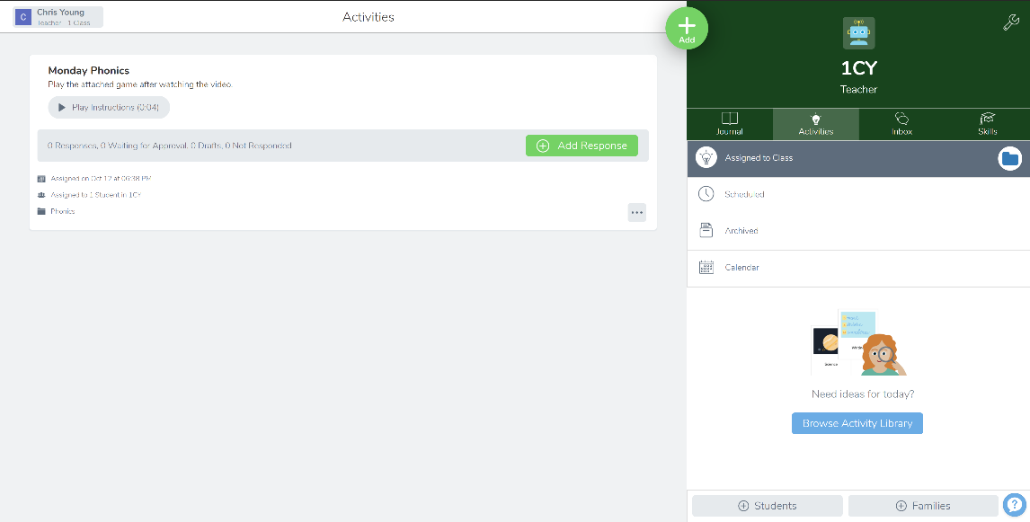
Attached to each ‘activity’ there will usually be video instructions that may include the White Rose Maths instructional video in the case of Maths or it may include a video from the class teacher delivering input on the lesson focus. Additional resources may be attached for either printing or for students to engage with.
To respond to an activity, you can select the green button marked ‘+ Add Response’ (highlighted in blue). The following image displays the options available for uploading work. 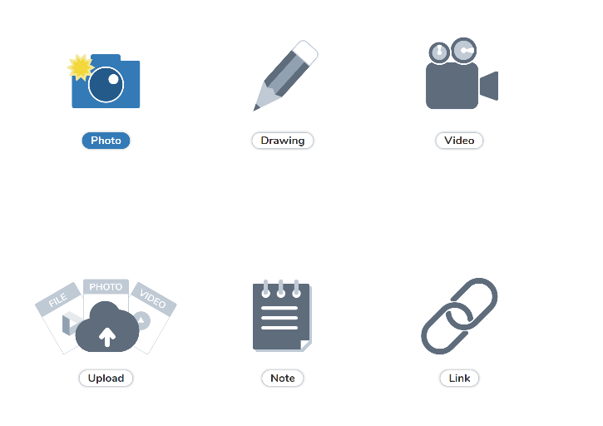

In many cases the most suitable option may be to take a photograph of the work completed and upload it so that the teacher can provide feedback.
A timetable of the children’s learning will be posted on the tab marked ‘Journal’ and activities will be marked with the date first so that parents and children can stay up to date with the day and weeks lesson intentions.
Also in the event of a lockdown teachers may arrange a virtual meeting with the class. You will be notified by the timetable of this and you may receive an invitation to this via the inbox on SeeSaw next to the activities tab.
The Seesaw Class app is available on iOS, Android, and Kindle Fire devices. You can also use Seesaw on the web using a computer or Chromebook on Chrome, Firefox, or Edge browser.
If you have any issues regarding difficulty logging into SeeSaw or difficulties accessing the content, please consult your child’s class teacher via the emails attached at the end of this document.

4.Tapestry
Foundation 1 and Foundation 2 parents and carers are familiar with tapestry and how we use it to upload photographs and observations of children. We will be using the app to set our home learning. Please remember that everything that you do is providing a learning opportunity for your child and they are continually learning new things about the world around them.

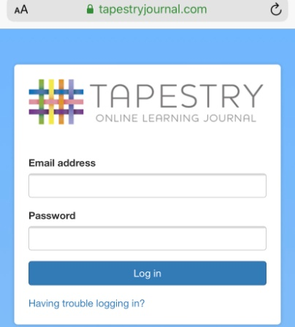

5. White Rose Maths
At Black Horse Hill Infant School we follow White Rose Maths to deliver high quality maths teaching and learning. This learning will be distributed via SeeSaw and will contain videos teaching your child how to learn and master the different areas of the curriculum. In addition there will be activity sheets to complete and upload back to your child’s class teacher.
There are other free resources available to access via : https://whiterosemaths.com/

6. Purple Mash
Your child has a subscription to Purple Mash which hosts a variety of curriculum focussed activities, creative tools, programs and games to support and inspire creative learning.
There is a link on the school website 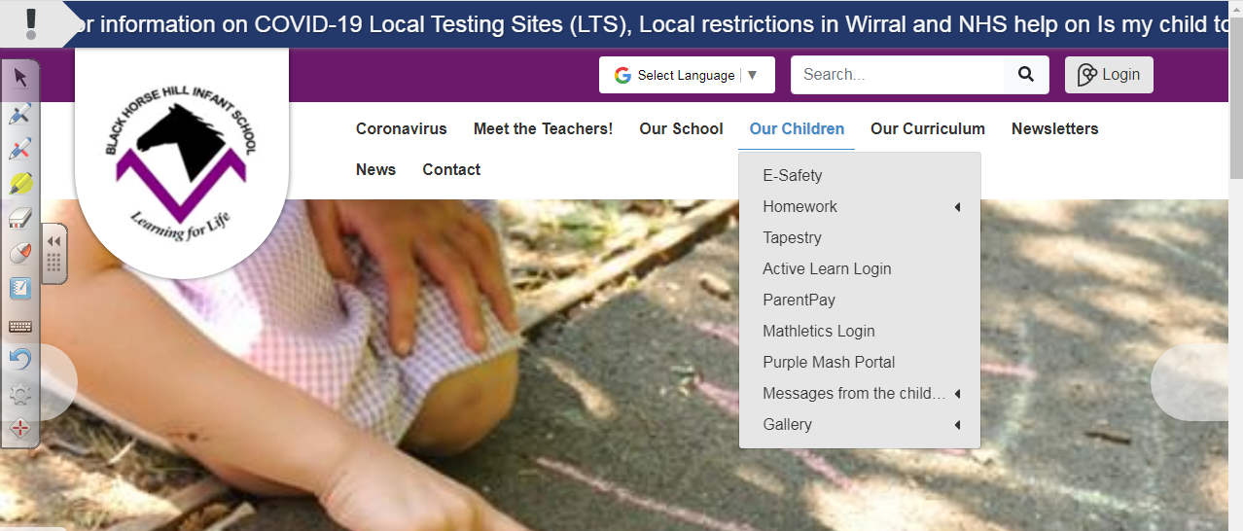
Please enter the username and password that has been sent home with your child.
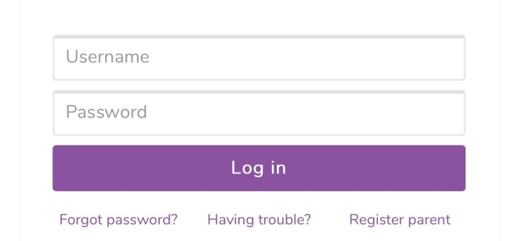
If you need a reminder of your child's login details, please contact your child's class teacher via the email address referenced at the end of this document.
Class teachers may direct pupils to complete specific activities (2Dos) within Purple Mash. When a task has been set by the class teacher, it will appear in the top tool bar as an alert.
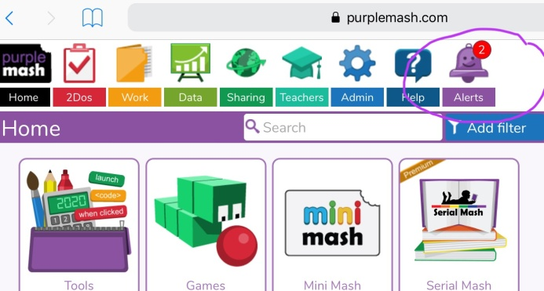

Additionally, your child may wish to use the search bar within Purple Mash to explore more activities if desired.

7. Bug Club Active Learn
Your child has a username and password for Active Learn where they can access online copies of the school reading scheme. Your child's class teacher will allocate books.
https://www.activelearnprimary.co.uk/login?c=0
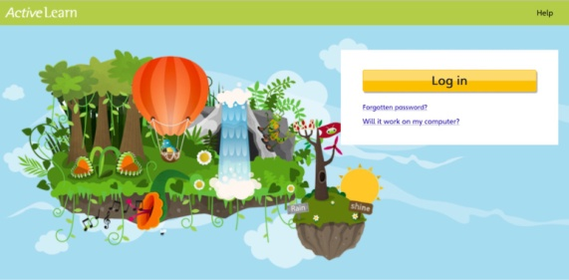
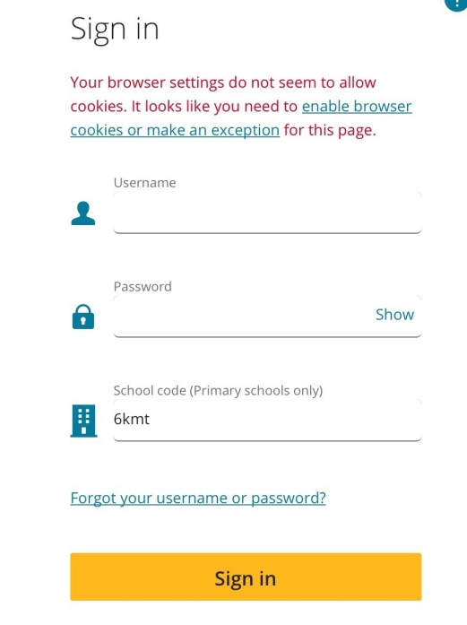
Don't forget to include the school code! 6kmt
If you need a reminder of your child's login details, please contact your child's class teacher via the email address referenced at the end of this document.

8. DfE Letters and Sounds
As part of your child’s home learning your teacher may direct you to specific videos to support their phonics. The following link will lead you to the DfE YouTube channel which could be used to support their understanding as well as be provided for home learning tasks.
https://www.youtube.com/channel/UCP_FbjYUP_UtldV2K_-niWw/featured

9. Mathletics
For parents in Year One and Two your child has a username and password for Mathletics where they can access interactive activities, games and challenges.
You can download the Mathletics App for iPads or access online.
www.mathletics.co.uk

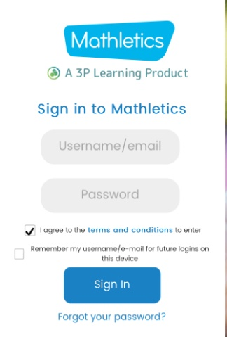
If you need a reminder of your child's login details, please contact your child's class teacher via the email address referenced at the end of this document.

10. E-Safety
When in school we talk about the importance of keeping safe online. When children are completing work or research online please make sure that they are supervised – whether through completing the work with the children or checking the sites they have been using. You can also make sure all parental controls and security settings are in place on the devices that your child is using to complete their online learning.
Please remind your child/children about keeping themselves safe online and what to do if they are unhappy with something they see online or if they are worried about anything.

The following websites have information for parents and children to help to keep safe online.

https://www.thinkuknow.co.uk/
https://www.nspcc.org.uk/keeping-children-safe/online-safety/

11.Oak Academy
Oak Academy is an online classroom which provides high quality video lessons and resources during 2020/21. With an uncertain year ahead, they can ease your remote and in-school learning. There is also a section for parents to support them with delivering home learning and home learning ideas.
https://www.thenational.academy/

12. BBC BITESIZE
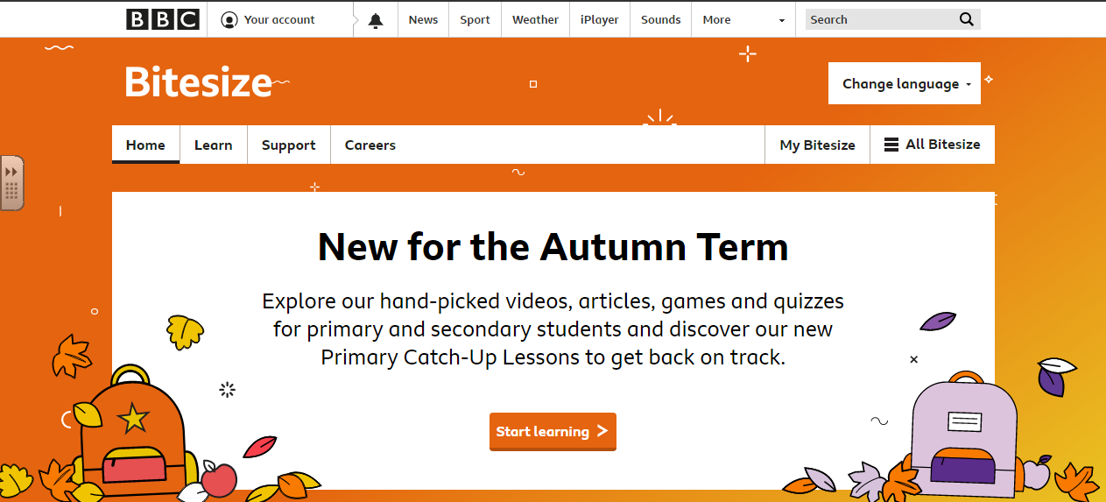
BBC Bitesize is another online area where they provide lots of interesting ideas and activities to support your child’s learning journey. Staff may signpost you to a video or resource via the following link.
https://www.bbc.co.uk/bitesize/levels/z3g4d2p

13. Communication
During school hours (Mon-Fri, 9.00-15.30), you can email your child's class teacher to share learning and to ask for advice about your child's learning. The class teacher will aim to respond to you as soon as possible within school hours.
F1 - Mrs Honeybourne- shoneybourne@blackhorsehill-infant.wirral.sch.uk
F2BE Mrs Bancroft- sbancoft@blackhorsehill-infant.wirral.sch.uk
F2SLP Mrs Lucan- snolan@blackhorsehill-infant.wirral.sch.uk
Yr1 Mr Young- chrisyoung@blackhorsehill-infant.wirral.sch.uk
Yr1 Mr Hamm dhamm@blackhorsehill-infant.wirral.sch.uk
Yr2 Mrs Astbury eastbury@blackhorsehill-infant.wirral.sch.uk
Yr2 Miss Murphy- tmurphy@blackhorsehill-infant.wirral.sch.uk
Mrs McLeod- rachel@blackhorsehill-infant.wirral.sch.uk

Please note that these email addresses will only be active during the period of school closure and will only be accessed by teachers during school hours. Please understand that the teachers' ability to respond to emails in a timely manner is dependent on their personal circumstances. Communication can also be directed to schooloffice@blackhorsehill-infant.wirral.sch.uk and we will forward your enquiry to the member of staff who is able to help.

Child Protection and Safeguarding concerns should be directed to schooloffice@blackhorsehill-infant.wirral.sch.uk
Alternatively, parents and carers can refer child protection concerns directly to the Integrated Front Door: 0151 606 2008 (9am-5pm). Outside of these hours call 0151 677 6557. In an emergency always dial 999.
We will continue to keep you up to date with all the latest information.

14. Twitter
In order to keep Black Horse Hill Infant Schools Twitter feed up and running, it would be lovely to have examples of the children's home learning and activities to share. Don’t forget to tag us into any school related tweets that you send, '@BHHInfant' or to your child’s class twitter handle.
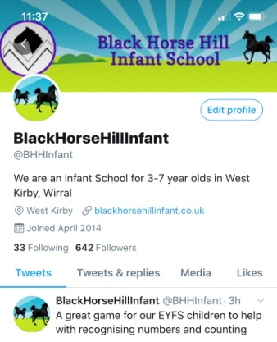
15.Zoom
Zoom is a video-chatting tool. Typically, you don't need a Zoom account because you are joining a meeting scheduled by the teacher (only meeting hosts need an account). We will use Zoom during lockdown to provide face to face sessions so children can see their classmates and teacher.
In order for these Zoom sessions to be successful, the following guidelines must be adhered to. If any of the following guidelines are not met, it is possible that your child’s class teacher may terminate the sessions.
- Parents/Carers must inform school if they do not consent to Zoom sessions taking place online.
- Zoom sessions should take place in a family room, such as the dining room or lounge, not in a bedroom.
- A parent or carer must be available at the start of the Zoom session; they then must stay within hearing distance of the session throughout.
- Children are requested not to use headphones.
- All Zoom sessions are timetabled in advance by your child’s class teacher and an email will be sent out prior to the start of each Zoom session.
- Children should dress and behave appropriately, showing respect for others, as they would for a classroom based lesson.
- Zoom sessions are not to be recorded by either party.
- Zoom sessions are optional and as a result parents/carers to do not need to inform teachers if their child cannot attend.
Key Contacts

NHS 111
NHS 111 online https://111.nhs.uk/covid 19
DfE Helpline: 0800 046 8687 (questions about COVID-19 related to education, open 8am-6pm Monday - Friday)
Email: DfE.coronavirushelpline@education.gov.uk
Public Health England North West: 0344 225 0562

Our preferred method of communication during a school closure is email. We will use email and text messages to send you important information and updates. If your contact details change during school closures can you please email the school office to let them know.
We wish to reiterate that the purpose of the school closure is to ensure that all families are given the opportunity to fully observe the restrictions observed by the government, to protect our health and to ensure our safety. This is most important of all.
C YOUNG & R MCLEOD
Updated January 2021

